Optimize your resume to get more job interviews

This free resume template will help you write an ATS-friendly resume. But how do you know what the hiring manager is looking for? What skills and experience should you list to show you’re the best candidate?

Jobscan’s resume scanner helps you optimize your resume for each job listing so that your application is more attractive to recruiters and hiring managers.

An optimized resume leads to more responses, more interviews, and more offers for the jobs you really want.

“Honestly, it was like the floodgates opened. Within a week…I was absolutely flooded with contacts and people reaching out.” Kelly, South Carolina, Jobscan User

”It’s the greatest tool that I have seen when it comes to searching for jobs.” Mark Stark, Career Success Coach

“We’re seeing easily 30% or more increase in calls from recruiters when our students use Jobscan to tailor their resumes.” Jeffrey Stubbs, Director, Baylor University Career Center

It’s frustrating to apply for dozens of jobs and not get any interviews. Use Jobscan to optimize your resume, cover letter, and LinkedIn profile.

90% of Jobscan Premium users landed an interview.

Jobscan users have been hired by:

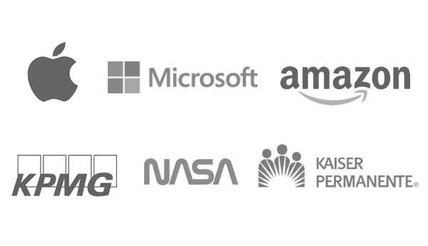


MADDISON ABBOTT

City, State Zip | (206) 555-5555 | maddisonabbott@email.com
linkedin.com/in/your-name-here

Add a strong resume summary here that highlights what it is you do, the types of companies you’ve worked with, and why you’re great at your job. Include experience, specializations, areas of interest, etc.

SKILLS AND ACCOMPLISHMENTS

- SKILL TOPIC 1 (e.g.: Software Engineering or Warehouse Management): Skill 1 | Skill 2 | Skill 3 ...
- SKILL TOPIC 2: Skill 1 | Skill 2 | Skill 3 | Skill 4 | Skill 5…
- SKILL TOPIC 3: Skill 1 | Skill 2 | Skill 3 | Skill 4 …

- ACCOMPLISHMENT 1: [Action verb] [brief explanation of accomplishment] resulting in [quantifiable outcome. Using %, $, etc. will draw the eye and make an impact]
- ACCOMPLISHMENT 2: ...
- ACCOMPLISHMENT 3: ...

WORK EXPERIENCE

JOB TITLE | Company 4, Location (MM/YYYY) – Present
This is where you write about your experience. Do not simply list your day-to-day job duties. Work in resume keywords that are most relevant to the job for which you’re applying. Provide context to the skills and accomplishments above.

JOB TITLE | Company 3, Location (MM/YYYY) – (MM/YYYY)
Because you listed skills and accomplishments above using this hybrid format, you can afford to write a little bit less in your experience section. Expand to two pages if necessary, but keeping your resume to one page is a good goal to have (unless you have over 10-15 years of relevant experience).

JOB TITLE | Company 2, Location (MM/YYYY) – (MM/YYYY)
It’s OK to leave positions off your resume if they aren’t relevant to the job you’re pursuing. Unless the experience is crucial, you can also go into fewer details on older positions.

JOB TITLE | Company 1, Location (MM/YYYY) – (MM/YYYY)
Barely relevant positions deep in your work history can be summed up in a quick line or two.

EDUCATION

DEGREE | College Name, Location Graduation Year (YYYY)

